Technical Architecture Document

1. System Overview

Product
SmartSpray — AI-Powered Precision Crop Spraying System
SmartSpray is a local-first AI + IoT system consisting of:
- A Flutter mobile application
- A Python/FastAPI backend
- A YOLO/OpenCV AI pipeline
- An ESP32 embedded controller
- A servo-controlled spray nozzle
- A DC pump
- A local database
- A laptop acting as the AI/backend edge computer
The system detects plant disease using a camera, estimates infection severity, determines a prototype spray level, and controls the physical sprayer.
The phone provides:
- Monitoring
- AUTO/ASSISTED/MANUAL mode selection
- Manual controls
- Detection information
- Device status
- Spray history
- Statistics

2. Architecture Decision

Recommended architecture
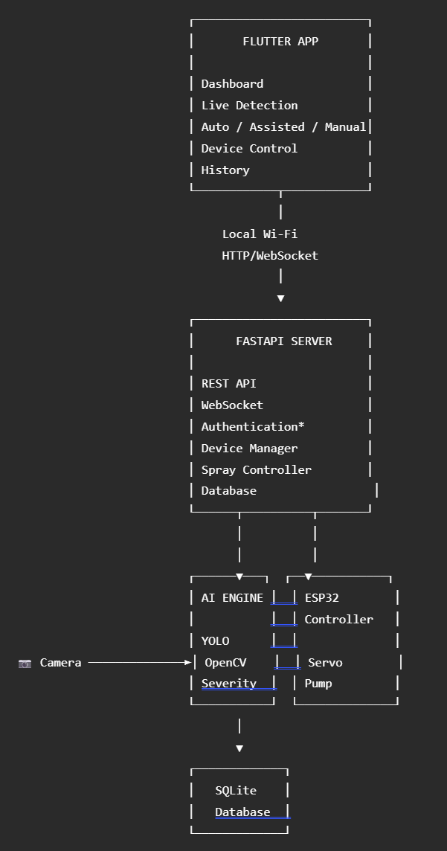* Authentication can be omitted from the first hackathon build.

Core principle
The architecture deliberately separates responsibilities:
Flutter = User interface
FastAPI = Application/backend layer
AI engine = Computer vision + decision engine
ESP32 = Real-time hardware controller
Database = Persistent application state/history
Do not put AI logic inside Flutter.
Do not let Flutter directly control the pump.
Do not make AWS/cloud infrastructure a dependency for V1.

3. Recommended Technology Stack

3.1 Mobile Application

Flutter + Dart
Recommendation: YES
Why:
- Single codebase
- Excellent Android support
- Fast UI development
- Easy API integration
- Good WebSocket support
- Good fit for a polished hackathon interface
- Can later target iOS/web/desktop if required

Flutter packages
Recommended:
dio
go_router
flutter_riverpod
web_socket_channel
shared_preferences
json_annotation
freezed
freezed_annotation
intl

Optional:
fl_chart
permission_handler
connectivity_plus

Don't add packages just because they exist. Keep dependencies small.

4. Backend

Python + FastAPI

Why FastAPI?
Your AI is already Python-based.
Using FastAPI means:
Flutter
↓
FastAPI
↓
AI

instead of introducing another backend language.
Advantages:
- Python AI integration
- Async support
- REST API
- WebSocket support
- Automatic OpenAPI documentation
- Pydantic validation
- Easy local development
Recommended libraries:
fastapi
uvicorn
pydantic
pydantic-settings
sqlalchemy
alembic
aiosqlite
pyserial
opencv-python
numpy
ultralytics
python-multipart

5. AI Stack

YOLO + OpenCV + PyTorch

YOLO
Use an Ultralytics YOLO model for the initial prototype.
Potential pipeline:
Camera frame
↓
YOLO
↓
Plant / leaf detection
↓
Disease detection
↓
Segmentation
↓
Severity calculation

OpenCV
Used for:
- Camera access
- Frame preprocessing
- Image resizing
- Drawing bounding boxes
- Displaying detection results
- Image transformations
- Camera calibration

PyTorch
Used for:
- Model training
- Model loading
- Inference
- GPU acceleration
Your laptop GPU can be used during development.

6. AI Model Architecture
For V1, don't build a giant disease-classification system.
Start with:
Crop:
Tomato

Classes:
1. Healthy
2. Diseased

Then optionally identify:
Disease:
Early Blight

For severity:
Leaf area
↓
Diseased pixel area
↓
infection_percentage

Formula:
infection_percentage =
(diseased_area / total_leaf_area) × 100

Then map the percentage to a prototype spray level:
0% → NONE
1–25% → LOW
26–60% → MEDIUM
>60% → HIGH

These values are prototype rules, not real pesticide dosage recommendations.

7. Embedded System

ESP32
ESP32 is responsible for deterministic physical control.
It should NOT run the YOLO model.

ESP32 responsibilities
- Servo control
- Pump control
- Reading optional sensors
- Receiving commands
- Reporting device status
- Emergency stop handling
- Watchdog/failsafe
- Returning command acknowledgements

Example command
SPRAY,87,1000

Meaning:
Servo angle = 87°
Pump duration = 1000 ms

The ESP32 should return:
ACK,SPRAY_STARTED

and later:
ACK,SPRAY_COMPLETED

8. Hardware Communication

V1 — USB Serial
Recommended for the first working prototype.
Laptop
│
USB
│
ESP32

Why?
Because it is:
- Simple
- Reliable
- Easy to debug
- Low latency
- No Wi-Fi configuration required

V2 — Wi-Fi
Later:
Laptop
│
Wi-Fi
│
ESP32

Use this when you want the physical device to be more independent.
For the hackathon, USB serial is the safer starting point.

9. Mobile ↔ Backend Communication
Use two communication methods.

REST API
Use REST for:
- Getting device information
- Getting history
- Changing modes
- Starting/stopping operations
- Getting statistics
- Configuration
Example:
GET /api/v1/device/status
GET /api/v1/detections
GET /api/v1/sprays
POST /api/v1/device/mode
POST /api/v1/spray/manual
POST /api/v1/emergency-stop

WebSocket
Use WebSocket for live events.
FastAPI
↕
WebSocket
↕
Flutter

Events:
DEVICE_CONNECTED
DEVICE_DISCONNECTED
PLANT_DETECTED
DISEASE_DETECTED
SEVERITY_UPDATED
SPRAY_RECOMMENDED
SPRAY_STARTED
SPRAY_COMPLETED
ERROR

This avoids repeatedly polling the backend.

10. Backend Internal Architecture
FastAPI should not contain everything in main.py.
Use layered architecture:
API layer
↓
Service layer
↓
Repository layer
↓
Database

Example:
Flutter
↓
API endpoint
↓
SprayService
↓
DeviceService
↓
ESP32Controller
↓
Hardware

This makes the system easier to maintain.

11. Complete Project Structure
smartspray/
│
├── README.md
├── .gitignore
├── .env.example
├── docker-compose.yml
├── Makefile
│
├── backend/
│ │
│ ├── requirements.txt
│ ├── pyproject.toml
│ │
│ ├── app/
│ │ ├── __init__.py
│ │ ├── main.py
│ │ │
│ │ ├── core/
│ │ │ ├── config.py
│ │ │ ├── logging.py
│ │ │ └── security.py
│ │ │
│ │ ├── api/
│ │ │ ├── router.py
│ │ │ │
│ │ │ └── v1/
│ │ │ ├── __init__.py
│ │ │ ├── device.py
│ │ │ ├── detection.py
│ │ │ ├── spraying.py
│ │ │ ├── history.py
│ │ │ ├── statistics.py
│ │ │ └── websocket.py
│ │ │
│ │ ├── models/
│ │ │ ├── device.py
│ │ │ ├── detection.py
│ │ │ ├── spray_event.py
│ │ │ ├── calibration.py
│ │ │ └── user.py
│ │ │
│ │ ├── schemas/
│ │ │ ├── device.py
│ │ │ ├── detection.py
│ │ │ ├── spraying.py
│ │ │ ├── calibration.py
│ │ │ └── user.py
│ │ │
│ │ ├── services/
│ │ │ ├── device_service.py
│ │ │ ├── detection_service.py
│ │ │ ├── spray_service.py
│ │ │ ├── calibration_service.py
│ │ │ └── statistics_service.py
│ │ │
│ │ ├── repositories/
│ │ │ ├── device_repository.py
│ │ │ ├── detection_repository.py
│ │ │ ├── spray_repository.py
│ │ │ └── calibration_repository.py
│ │ │
│ │ ├── ai/
│ │ │ ├── model_loader.py
│ │ │ ├── detector.py
│ │ │ ├── segmenter.py
│ │ │ ├── severity.py
│ │ │ └── decision_engine.py
│ │ │
│ │ ├── hardware/
│ │ │ ├── esp32_controller.py
│ │ │ ├── serial_manager.py
│ │ │ ├── servo_controller.py
│ │ │ └── pump_controller.py
│ │ │
│ │ └── websocket/
│ │ ├── manager.py
│ │ └── events.py
│ │
│ ├── migrations/
│ │ ├── alembic.ini
│ │ └── versions/
│ │
│ ├── tests/
│ │ ├── unit/
│ │ ├── integration/
│ │ └── api/
│ │
│ └── data/
│ ├── models/
│ ├── datasets/
│ └── captures/
│
├── flutter_app/
│ │
│ ├── pubspec.yaml
│ ├── analysis_options.yaml
│ │
│ ├── android/
│ ├── ios/
│ ├── web/
│ │
│ └── lib/
│ ├── main.dart
│ │
│ ├── app/
│ │ ├── app.dart
│ │ ├── router.dart
│ │ └── theme.dart
│ │
│ ├── core/
│ │ ├── constants/
│ │ ├── errors/
│ │ ├── network/
│ │ └── utils/
│ │
│ ├── models/
│ │ ├── device.dart
│ │ ├── detection.dart
│ │ ├── spray_event.dart
│ │ └── statistics.dart
│ │
│ ├── services/
│ │ ├── api_service.dart
│ │ ├── websocket_service.dart
│ │ └── device_service.dart
│ │
│ ├── features/
│ │ ├── dashboard/
│ │ ├── detection/
│ │ ├── control/
│ │ ├── history/
│ │ └── settings/
│ │
│ └── widgets/
│ ├── status_card.dart
│ ├── detection_card.dart
│ ├── spray_button.dart
│ └── mode_selector.dart
│
├── esp32/
│ │
│ ├── platformio.ini
│ └── src/
│ ├── main.cpp
│ ├── config.h
│ ├── communication.cpp
│ ├── communication.h
│ ├── servo.cpp
│ ├── servo.h
│ ├── pump.cpp
│ ├── pump.h
│ ├── safety.cpp
│ └── safety.h
│
├── ml/
│ │
│ ├── datasets/
│ ├── notebooks/
│ ├── training/
│ │ ├── train.py
│ │ ├── evaluate.py
│ │ └── export.py
│ └── configs/
│ └── dataset.yaml
│
└── docs/
├── architecture.md
├── api.md
├── hardware.md
├── ai.md
└── calibration.md

This may look large, but most folders will initially contain only a few files.
The point is to prevent the project from becoming one enormous unmaintainable script.

12. Database Architecture
For the hackathon:

SQLite
Use SQLite initially because:
- Zero configuration
- Local
- Fast enough
- Easy backup
- No database server required

Later
Move to PostgreSQL when the system becomes multi-user/cloud-based.

13. Database ER Diagram
users
│
│ 1:N
▼
devices
│
├───────────────┐
│ │
│ 1:N │ 1:N
▼ ▼
detections spray_events
│ │
│ │
└──────┬────────┘
│
▼
sessions

devices
│
│ 1:N
▼
calibrations

For the hackathon, users can be omitted entirely.

14. users Table

Purpose
Stores people who use the system.
Field | Type | Description
id | UUID | Primary key
name | VARCHAR | User's name
email | VARCHAR | Login email
password_hash | VARCHAR | Hashed password
role | VARCHAR | farmer/admin/researcher
created_at | TIMESTAMP | Account creation
updated_at | TIMESTAMP | Last update

V1
You can skip authentication and this table.
Don't build login just to make the application look more professional.

15. devices Table

Purpose
Represents each physical SmartSpray device.
Field | Type | Description
id | UUID | Primary key
name | VARCHAR | Device name
device_uid | VARCHAR | ESP32 unique identifier
status | VARCHAR | online/offline/error
mode | VARCHAR | auto/assisted/manual
firmware_version | VARCHAR | ESP32 firmware
last_seen_at | TIMESTAMP | Last communication
created_at | TIMESTAMP | Creation time
updated_at | TIMESTAMP | Last update
Example:
id:
a1b2c3

name:
SmartSpray Prototype 01

device_uid:
ESP32-A82F91

status:
online

mode:
assisted

16. detections Table

Purpose
Stores AI observations.
Field | Type | Description
id | UUID | Primary key
device_id | UUID | FK → devices
session_id | UUID | FK → sessions
disease | VARCHAR | Predicted disease
confidence | FLOAT | AI confidence
severity_percent | FLOAT | Estimated infection
spray_level | VARCHAR | none/low/medium/high
image_path | TEXT | Optional image
bbox_x | FLOAT | Bounding box
bbox_y | FLOAT | Bounding box
bbox_width | FLOAT | Bounding box
bbox_height | FLOAT | Bounding box
created_at | TIMESTAMP | Detection time
Example:
Disease:
Early Blight

Confidence:
0.94

Severity:
42.5

Spray level:
medium

17. spray_events Table

Purpose
Stores every physical spraying operation.
Field | Type | Description
id | UUID | Primary key
device_id | UUID | FK → devices
detection_id | UUID | Optional FK → detections
session_id | UUID | FK → sessions
mode | VARCHAR | auto/assisted/manual
servo_angle | FLOAT | Nozzle angle
duration_ms | INTEGER | Pump duration
estimated_volume_ml | FLOAT | Estimated liquid
status | VARCHAR | requested/started/completed/failed
error_message | TEXT | Failure details
started_at | TIMESTAMP | Start
completed_at | TIMESTAMP | Completion
This table is critical because it records what the physical device actually did.

18. calibrations Table

Purpose
Stores hardware calibration values.
Field | Type | Description
id | UUID | Primary key
device_id | UUID | FK → devices
calibration_type | VARCHAR | pump/servo/camera
parameter | VARCHAR | Specific parameter
value | FLOAT | Calibration value
unit | VARCHAR | ms/ml/degree/etc.
created_at | TIMESTAMP | Creation time
Example:
pump
1000 ms
8.2 ml

Or:
servo
center
90°

19. sessions Table

Purpose
Groups a continuous spraying/scanning operation.
Example:
A farmer scans one crop row for 10 minutes.
That entire operation becomes one session.
Field | Type | Description
id | UUID | Primary key
device_id | UUID | FK → devices
mode | VARCHAR | auto/assisted/manual
started_at | TIMESTAMP | Start
ended_at | TIMESTAMP | End
plants_scanned | INTEGER | Number scanned
infected_count | INTEGER | Number infected
sprayed_count | INTEGER | Number sprayed
estimated_liquid_ml | FLOAT | Total liquid
status | VARCHAR | active/completed/failed

20. Relationships

User → Device
One user can own multiple devices.
User 1 ───── N Devices

Device → Detection
One device can generate many AI detections.
Device 1 ───── N Detections

Detection → Spray Event
One detection may produce zero or one spray event.
Detection 1 ───── 0..1 Spray Event

For example:
Healthy:
Detection
↓
No spray

Diseased:
Detection
↓
Spray event

Device → Calibration
One device can have multiple calibration records.
Device 1 ───── N Calibrations

Session → Detection
One session can contain many detections.
Session 1 ───── N Detections

Session → Spray Events
One session can contain many spray events.
Session 1 ───── N Spray Events

21. Database Indexes
At minimum:
devices.device_uid
devices.status
detections.device_id
detections.created_at
spray_events.device_id
spray_events.created_at
spray_events.session_id
sessions.device_id
sessions.started_at

This isn't critical for six plants in a hackathon, but it prevents bad database design later.

22. API Structure
Base URL:
/api/v1

Device
GET /devices
GET /devices/{device_id}
GET /devices/{device_id}/status
POST /devices/{device_id}/mode
POST /devices/{device_id}/connect

Detection
GET /detections
GET /detections/{detection_id}
GET /detections/latest

Spray
POST /spray/auto
POST /spray/manual
POST /spray/stop
GET /spray/history
GET /spray/{spray_id}

Sessions
POST /sessions
GET /sessions
GET /sessions/{session_id}
POST /sessions/{session_id}/stop

Statistics
GET /statistics/today
GET /statistics/session/{session_id}

WebSocket
/ws/device/{device_id}

23. API Request Flow — AUTO
Camera
↓
AI detector
↓
DetectionService
↓
DecisionEngine
↓
SprayService
↓
ESP32Controller
↓
ESP32
↓
Servo
↓
Pump

The Flutter application receives the events through WebSocket.

24. API Request Flow — MANUAL
Flutter
↓
POST /spray/manual
↓
FastAPI
↓
Safety validation
↓
SprayService
↓
ESP32Controller
↓
ESP32
↓
Pump

The server should reject unsafe/invalid values.
For example:
servo_angle < 0

should be rejected.
Similarly:
duration_ms > configured_max_duration

should be rejected.
Do not allow the Flutter client to send arbitrary hardware commands without backend validation.

25. Safety Architecture
This is particularly important because the system controls a physical pump.

Layer 1 — Flutter
User interface.

Layer 2 — FastAPI
Validates:
- Mode
- Servo angle
- Pump duration
- Device state

Layer 3 — ESP32
Validates again.
This is important because the ESP32 should never blindly trust a command.
Example:
MAX_SERVO_ANGLE = 160°
MAX_PUMP_DURATION = 3000 ms

The exact values should be determined by your hardware.

26. Emergency Stop
The emergency stop must work independently of the AI.
Recommended:
Battery
│
▼
Physical Emergency Stop
│
▼
Pump Power

Software:
Flutter
↓
STOP
↓
FastAPI
↓
ESP32
↓
Pump OFF

The physical emergency stop should remain effective even if:
- Laptop crashes
- Phone disconnects
- Wi-Fi fails
- FastAPI crashes
- ESP32 software hangs

27. Environment Variables
Create:
.env

Never commit it.
Use:
.env.example

in Git.

Backend
APP_ENV=development
APP_HOST=0.0.0.0
APP_PORT=8000

DATABASE_URL=sqlite:///./data/smartspray.db

ESP32_CONNECTION=serial
ESP32_SERIAL_PORT=COM5
ESP32_BAUD_RATE=115200

AI_MODEL_PATH=./data/models/best.pt
AI_CONFIDENCE_THRESHOLD=0.50

SEVERITY_MILD_MAX=25
SEVERITY_MODERATE_MAX=60

MAX_SERVO_ANGLE=160
MIN_SERVO_ANGLE=20

MAX_PUMP_DURATION_MS=3000

CORS_ORIGINS=http://localhost:3000

On Linux:
ESP32_SERIAL_PORT=/dev/ttyUSB0

The COM port will vary by machine.

28. Flutter Configuration
Do not hardcode:
http://192.168.1.10:8000

inside random Dart files.
Use environment/configuration.
For development:
API_BASE_URL=http://192.168.1.10:8000/api/v1
WS_BASE_URL=ws://192.168.1.10:8000/ws

For production later:
API_BASE_URL=https://api.example.com/api/v1
WS_BASE_URL=wss://api.example.com/ws

29. Important Local Network Issue
Your phone and laptop must be able to communicate.
Recommended:
Wi-Fi
/ \
/ \
Phone Laptop
│
ESP32

The laptop should listen on:
0.0.0.0

not only:
127.0.0.1

Otherwise the phone cannot reach the backend.
You may also need to allow port 8000 through the laptop's firewall.

30. CORS
FastAPI needs to allow the Flutter client if appropriate for your architecture.
Development:
CORS_ORIGINS=*

is convenient but should not be used in a production deployment.
For the hackathon, restrict it once the network setup is known.

31. AI Model Configuration
Don't hardcode model parameters.
Use configuration:
AI_MODEL_PATH=./data/models/best.pt
AI_CONFIDENCE_THRESHOLD=0.5
AI_IMAGE_SIZE=640
AI_DEVICE=0

For CPU:
AI_DEVICE=cpu

For GPU:
AI_DEVICE=0

The actual setting depends on your PyTorch/CUDA installation.

32. AI Data Storage
Don't store every camera frame in the database.
That's bad architecture.
Instead:
Database
↓
Detection metadata

and optionally:
data/captures/
detection_001.jpg
detection_002.jpg

The database stores:
image_path = data/captures/detection_001.jpg

Later, cloud object storage can replace local files.

33. Logging
Use structured logs.
Examples:
INFO Device connected
INFO AI model loaded
INFO Plant detected
INFO Disease detected
INFO Spray command sent
INFO Spray completed

WARNING ESP32 disconnected

ERROR Pump command failed

Never rely only on print() statements once the project becomes complicated.

34. Error Handling
The backend should define clear error codes.
Examples:
DEVICE_OFFLINE
AI_NOT_READY
INVALID_SERVO_ANGLE
PUMP_TIMEOUT
ESP32_TIMEOUT
SPRAY_ALREADY_RUNNING
EMERGENCY_STOP_ACTIVE
INVALID_MODE

Flutter can convert these into human-readable messages.
Example:
ESP32_TIMEOUT

becomes:
"Device did not respond. Check the ESP32 connection."

35. State Machine
Don't let the system randomly switch between states.
Use explicit states.
OFFLINE
↓
CONNECTING
↓
READY
↓
SCANNING
↓
DETECTION
↓
DECISION
↓
POSITIONING
↓
SPRAYING
↓
COMPLETED
↓
READY

Error:
ANY STATE
↓
ERROR
↓
SAFE_STOP

This will eliminate many integration bugs.

36. Mode State Machine
AUTO
ASSISTED
MANUAL

Switching modes should only happen when the pump is OFF.
For example:
SPRAYING
↓
User changes MANUAL

should be rejected.
First:
SPRAYING
↓
PUMP OFF
↓
READY
↓
MANUAL

37. Security
For a local hackathon system, keep security simple.
Minimum:
- Don't expose the backend to the public internet.
- Don't commit passwords/API keys.
- Validate all hardware commands.
- Restrict CORS.
- Don't expose arbitrary shell commands through APIs.
- Use a physical emergency stop.
You do not need a complicated OAuth/Auth0 system for V1.

38. Configuration Management
Have three conceptual environments:
development
testing
production

For the hackathon, you'll primarily use:
development

Keep configuration separate from application logic.

39. Testing Strategy

AI tests
Test:
- Healthy plant
- Diseased plant
- Poor lighting
- Different angles
- Multiple leaves
- Partial occlusion

Backend tests
Test:
- Device status
- Mode switching
- Spray command validation
- Emergency stop
- Database writes
- WebSocket events

ESP32 tests
Test:
- Servo movement
- Pump ON/OFF
- Invalid commands
- Timeout
- Emergency stop
- Serial communication

Integration test
The most important test:
Camera
↓
AI
↓
FastAPI
↓
ESP32
↓
Servo
↓
Pump
↓
Database
↓
Flutter

Run this repeatedly before the hackathon.

40. Development Order
Do NOT let all six people start randomly building everything.
Use this sequence.

Stage 1 — Hardware
Make this work:
ESP32 → Servo
ESP32 → Pump

Stage 2 — AI
Make:
Webcam → YOLO → Disease

work independently.

Stage 3 — Backend
Make:
POST /spray

control the ESP32.

Stage 4 — Flutter
Build:
Dashboard
Mode selection
Manual controls
Detection result

using fake data initially.

Stage 5 — Integration
Connect:
AI → Backend → ESP32 → Hardware

Stage 6 — Real Flutter integration
Connect:
Flutter → Backend → real system

Stage 7 — Polish
Only after everything works:
- UI animations
- Charts
- Better graphics
- History
- Statistics
- Demo mode

41. Team Responsibilities
For six people:

Member 1 — AI
Dataset
YOLO
Training
Evaluation
Inference

Member 2 — Computer Vision
OpenCV
Segmentation
Severity
Camera
Calibration

Member 3 — ESP32
Servo
Pump
Serial/Wi-Fi
Safety
Firmware

Member 4 — Backend
FastAPI
Database
REST API
WebSocket
Hardware integration

Member 5 — Flutter
UI
Navigation
API integration
WebSocket
Manual controls

Member 6 — Integration/Product
Hardware enclosure
System integration
Testing
Demo workflow
Documentation
Presentation

42. What NOT to Do Technically
Avoid these common mistakes:

❌ One giant Python file
Don't put:
AI
FastAPI
serial
database
business logic

into main.py.

❌ Flutter directly talking to ESP32
Use:
Flutter → FastAPI → ESP32

instead.

❌ Cloud-first architecture
Don't introduce AWS just because it sounds impressive.
Your laptop already performs AI inference.

❌ Database for every video frame
Store detection events, not an infinite stream of images.

❌ AI controlling the pump without safety validation
Every physical command needs limits.

❌ Building the mobile app before testing the backend
First make:
Python → ESP32 → Pump

work.
Then expose it to Flutter.

43. Future Production Architecture
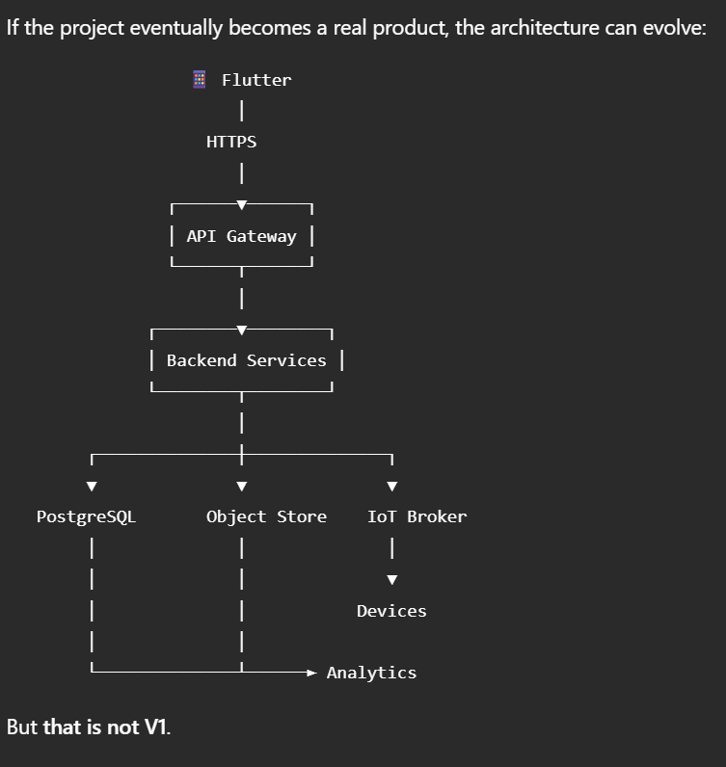

44. Final Recommended Stack
Layer | Technology | Reason
Mobile | Flutter/Dart | Cross-platform, fast UI
API | FastAPI/Python | Direct AI integration
AI | YOLO + PyTorch | Object detection/segmentation
CV | OpenCV | Camera/image processing
ORM | SQLAlchemy | Clean database abstraction
Migration | Alembic | Database version control
DB V1 | SQLite | Zero-config local database
DB later | PostgreSQL | Production scalability
Real-time | WebSocket | Live device/detection events
Hardware | ESP32 | Low-cost embedded control
Servo | PWM | Nozzle positioning
Pump | MOSFET/relay | Liquid actuation
Communication V1 | USB Serial | Reliable and simple
Communication V2 | Wi-Fi | Wireless device
ML training | PyTorch/Ultralytics | Model development
Deployment | Local laptop | No cloud dependency
Cloud V1 | None | Unnecessary complexity

45. Final Architecture Decision
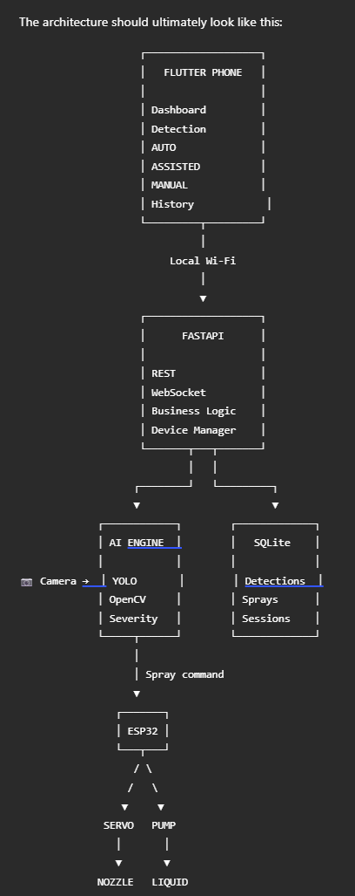

The critical design principle
Keep V1 local.
Your laptop is already powerful enough to run the AI. Your phone is already powerful enough to provide the UI. Your ESP32 is already capable of controlling the hardware.
Adding AWS, cloud inference, complex authentication, GPS, multiple crops, and autonomous navigation at this stage would make the project more fragile, not more impressive.
Build the vertical slice first:
AI detection → severity → Flutter result → FastAPI → ESP32 → servo/pump → spray → database record.
Once that works end-to-end, every additional feature becomes an incremental improvement instead of another unresolved dependency.

